

A Project Report On

**Grocery Delivery Application**

**Batch:** 2021 – 6518

**Center: Chennai**

Under the Guidance of,

**Chittaranjan Ghosh**

**Technical Trainer**

**EduBridge**

(School of coding)

**Introduction:**

Our project explains about the Grocery Delivery Application Website Name Grocery Store . This project mainly explains the various actions related to shop online. You can search various products and shuffle according to category. Our Project Include

**Modules:-**

* Admin Module
* Customer Module
* Cart Module
* Product Module
* Payment Module
* Transaction Module

I have developed this Application in **Java, JSP, Servlets, Spring Boot MVC, Spring REST, Thymeleaf and MySQL 8.** It’s a web-based projects so I have used **HTML, CSS, Ajax, JQuery JavaScript and Bootstrap also**.

The main feature of the project is to make shopping easier. You can access this website from anywhere and everywhere.

In Admin module, admin can add the Category and Products in the specific category. He can also view the total number of users at present in the website. And category and product details also. Admin can only see the admin page and cart if he wants to order something.

In Customer Module, customer can access the website and buy products and products to cart and buy and shuffle by category. New user can register and login after that to shop. In Cart, admin and user both can access, they can add the products and buy if they want. this gathers the important information of the customers. This information was used for determining the choices of the customer orders and their transactions.

In Payment module, the admin can have and monitor the transaction that are made by customers. This will save the transaction information as well as important matters that were done during shopping like ordering and paying.

In Transaction module, this feature will store the transactions made including their information and the reports every transaction in the corresponding tables.

**Software Requirements:**

**Front end:** Java/J2EE technologies (Servlet, JSP), HTML, CSS, JavaScript, Bootstrap, Ajax and jQuery

**Back end**: MySQL workbench 8.0.24CE.

**Middleware/Server:** Apache Tomcat v8.5. IDE: Eclipse IDE for Java EE Developers

**Browser:** Best result on Google Chrome

**Operating System:** Window 10

# Data Dictionary:

* Create Database grocerydb;
* create table Category (category_id integer not null auto_increment, category_name varchar(255), category_type varchar(255));
* create table admin(user_name varchar(40), password varchar(10), email varchar(50));
* create table seller(seller_id integer not null auto_increment, seller_name varchar(50), seller_contact bigint(10));

# Screenshots:-

**Home Page:**

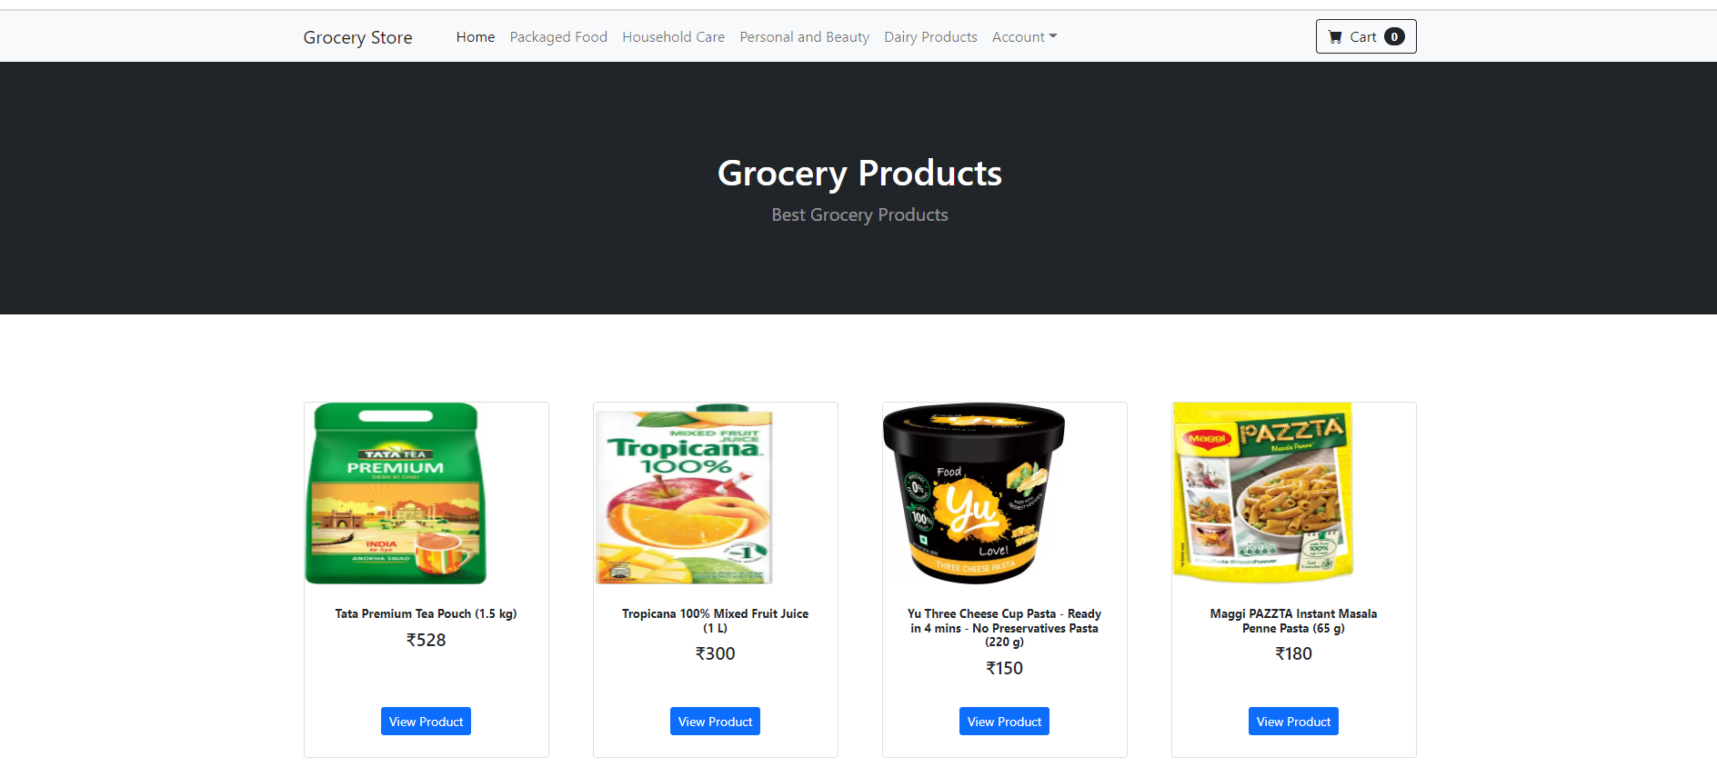

**Login Page:**

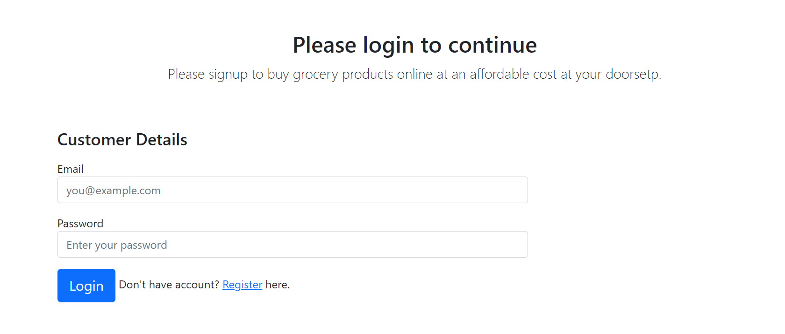

**Register Page:**

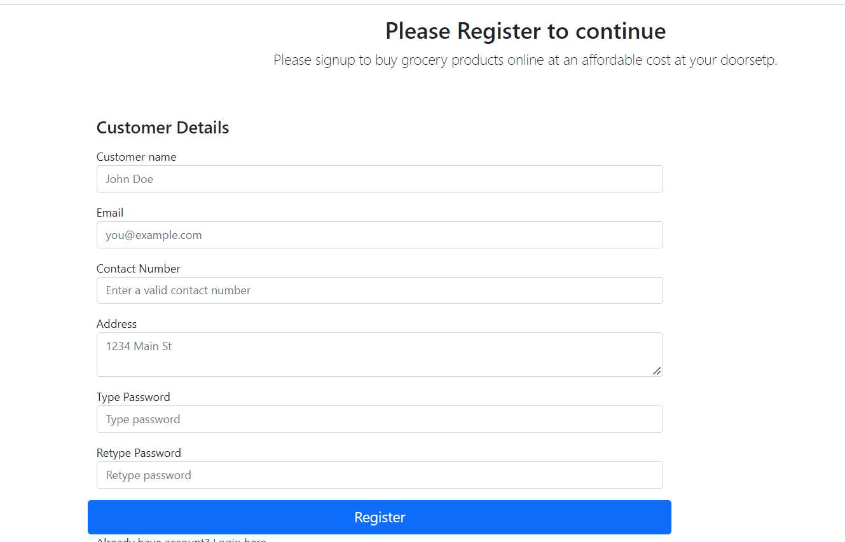

**Registering with data:**

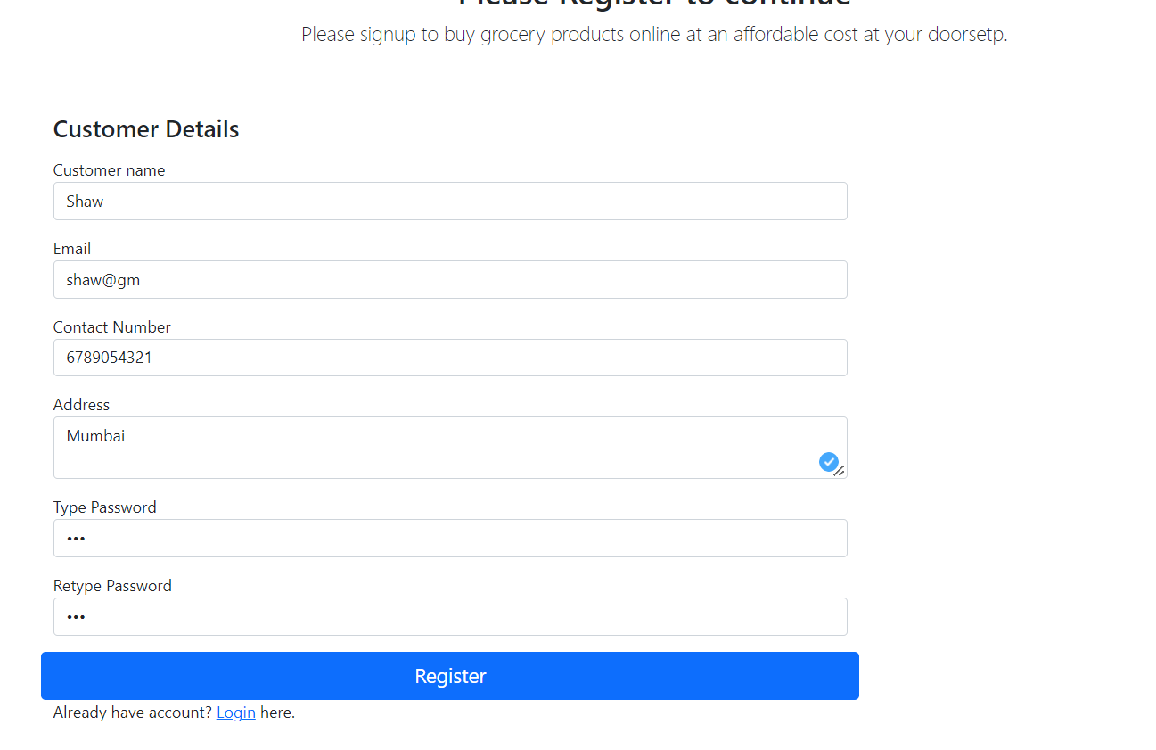

**SuccessFul Registeration Done.**

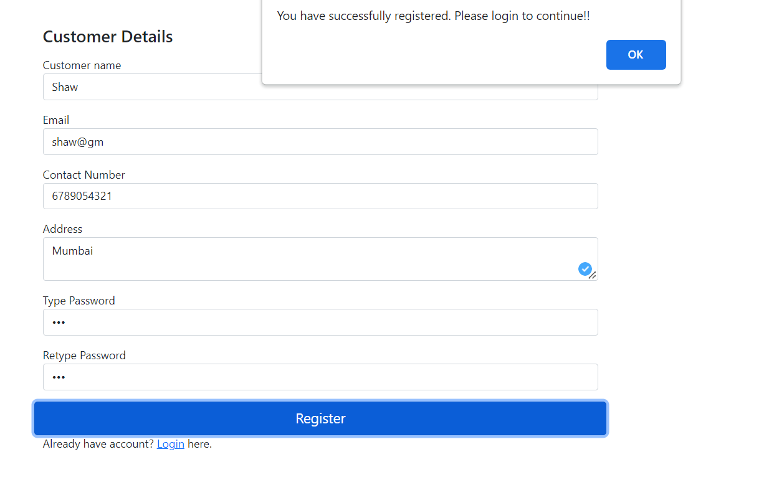

**Data Added in Database SuccessFully:**

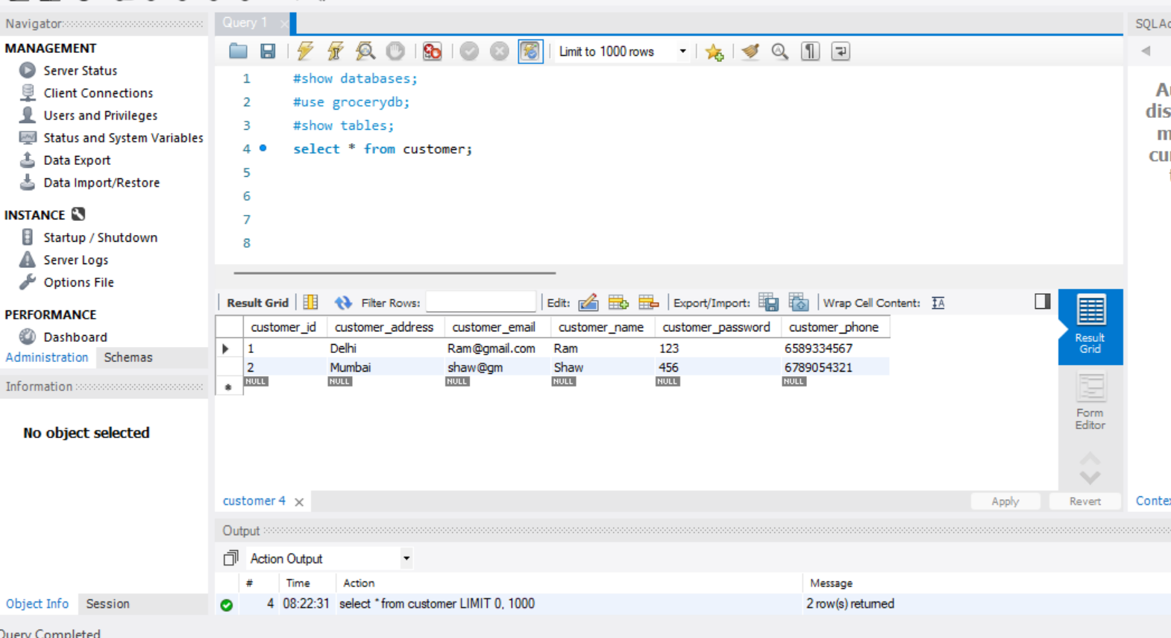

**Login With registered Details:**

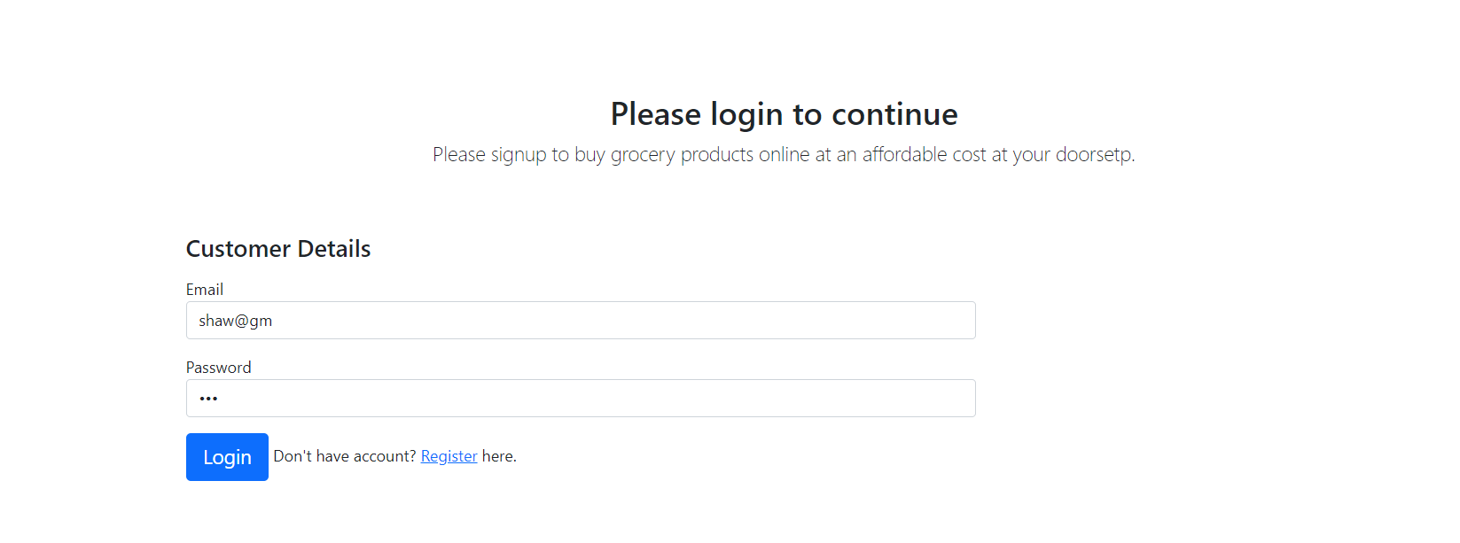

**Login with UserID:**

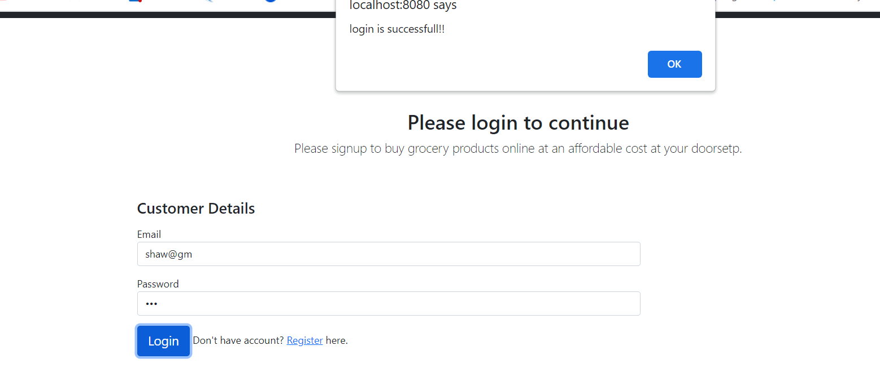

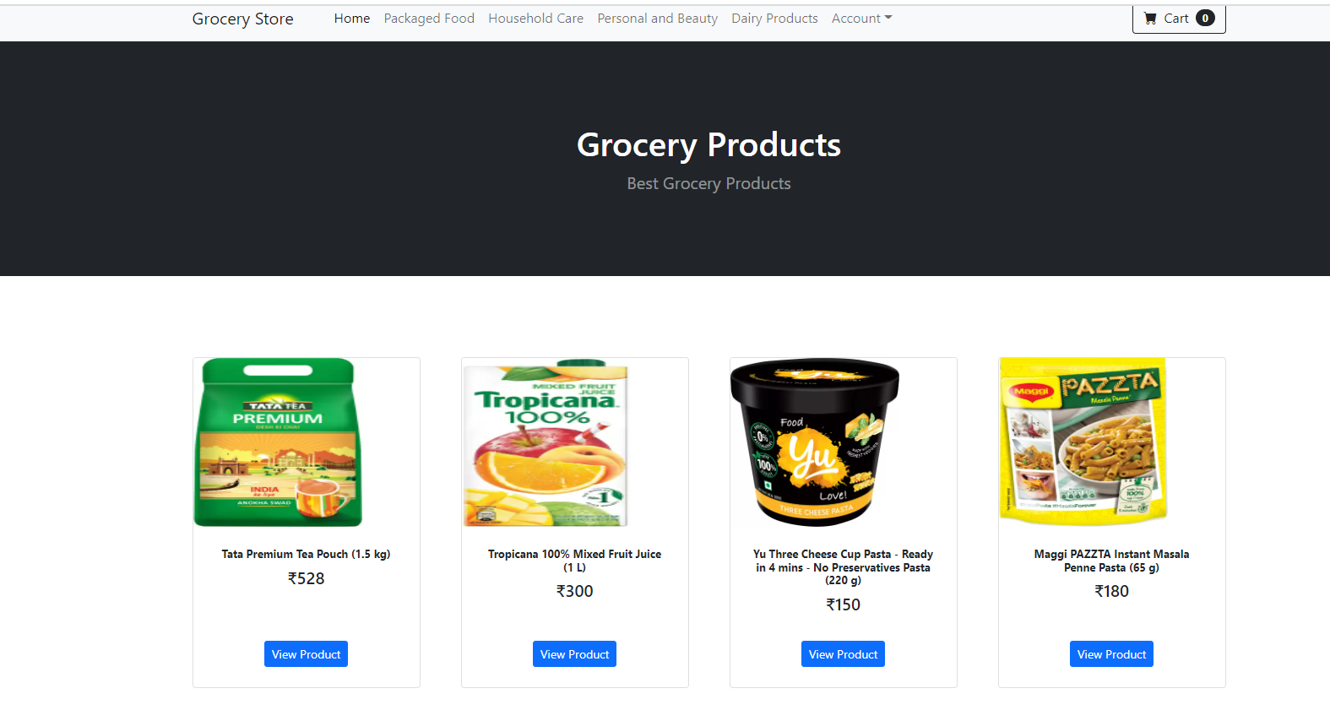

**View Products:**

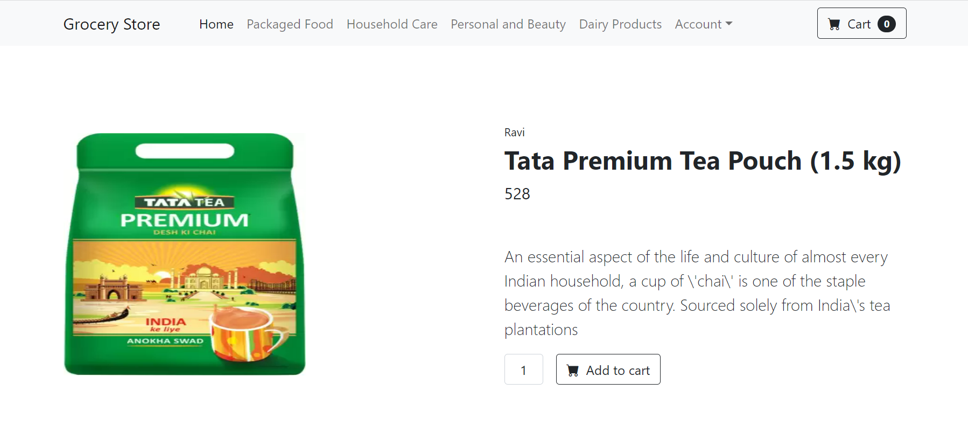

**Add to cart Tab:**

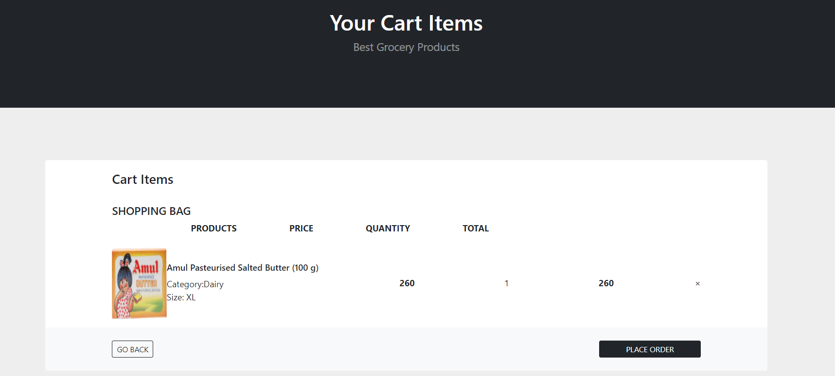

**Category Sections:**

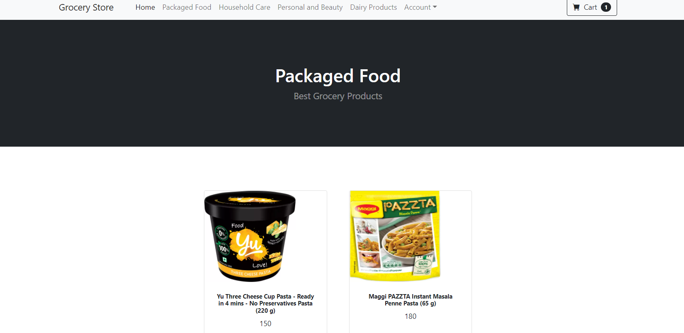

**Checkout Page:**

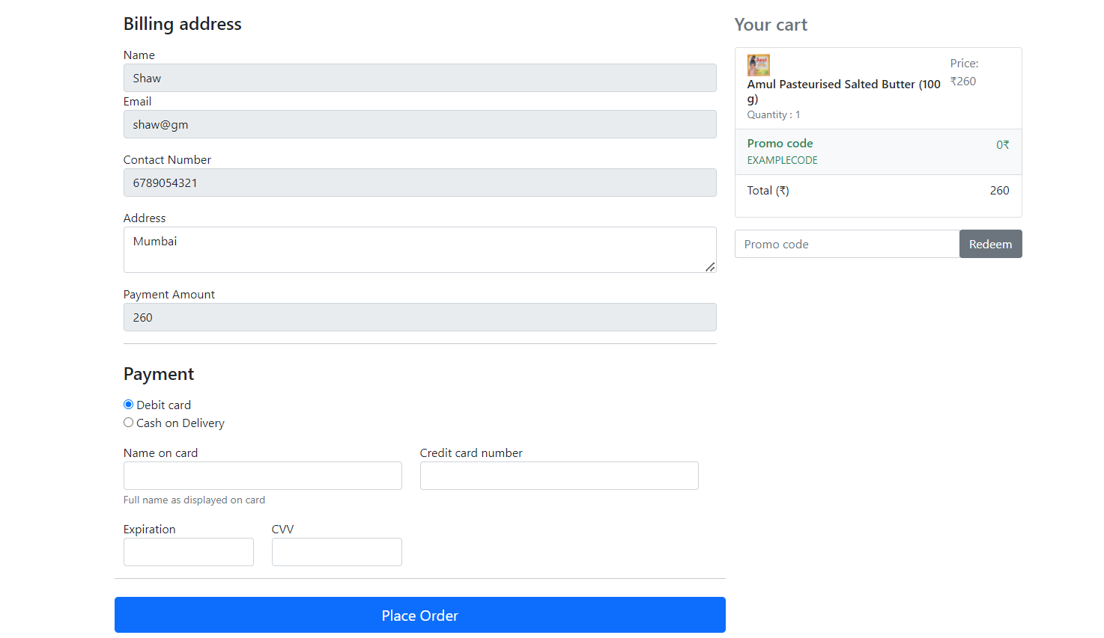

**Order status:**

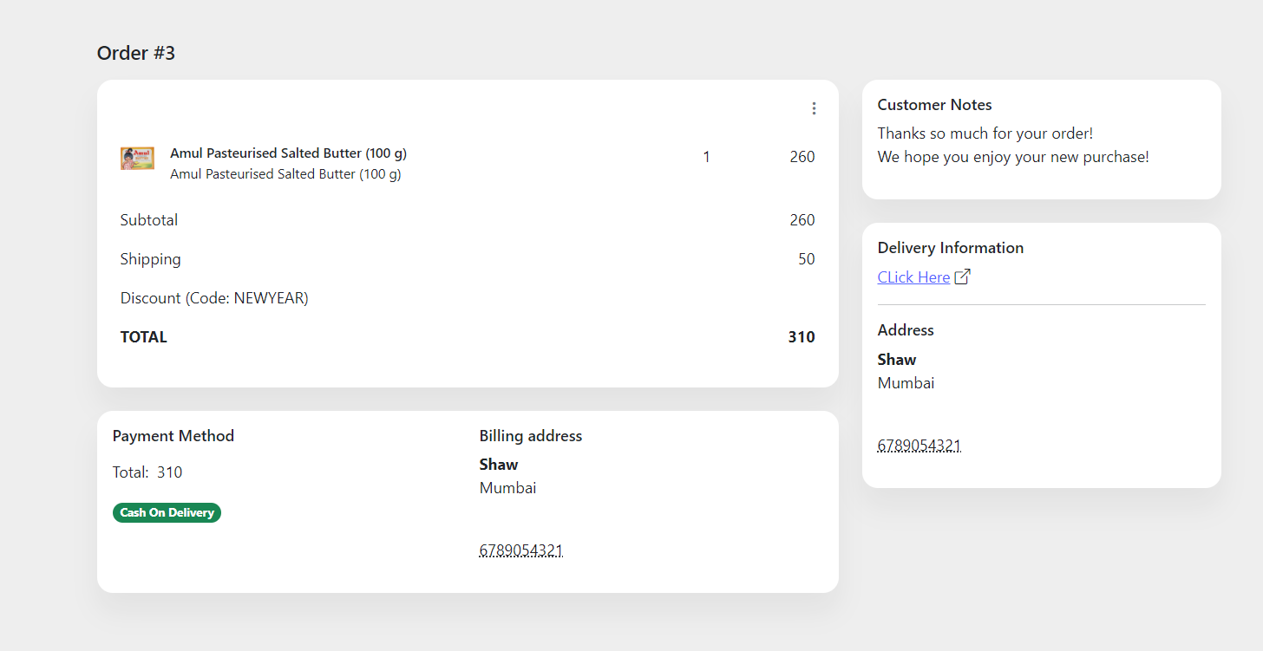

**Admin Login:**

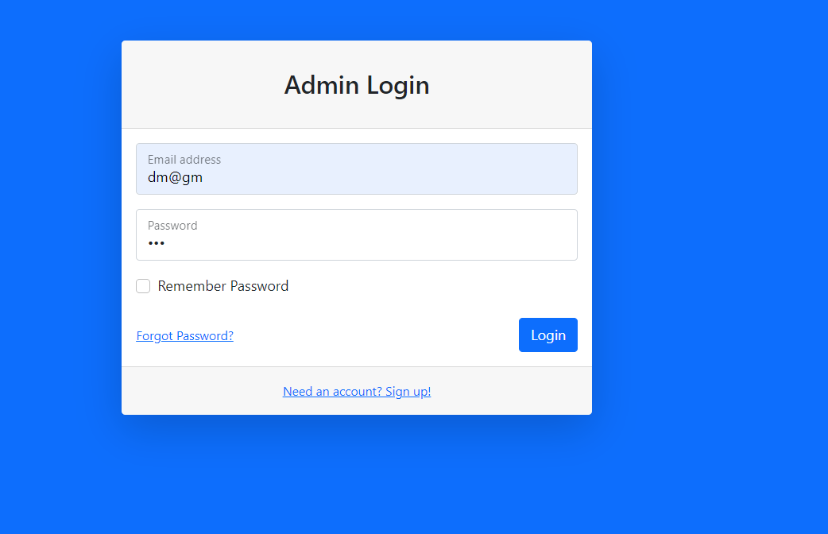

**Admin Dashboard:**

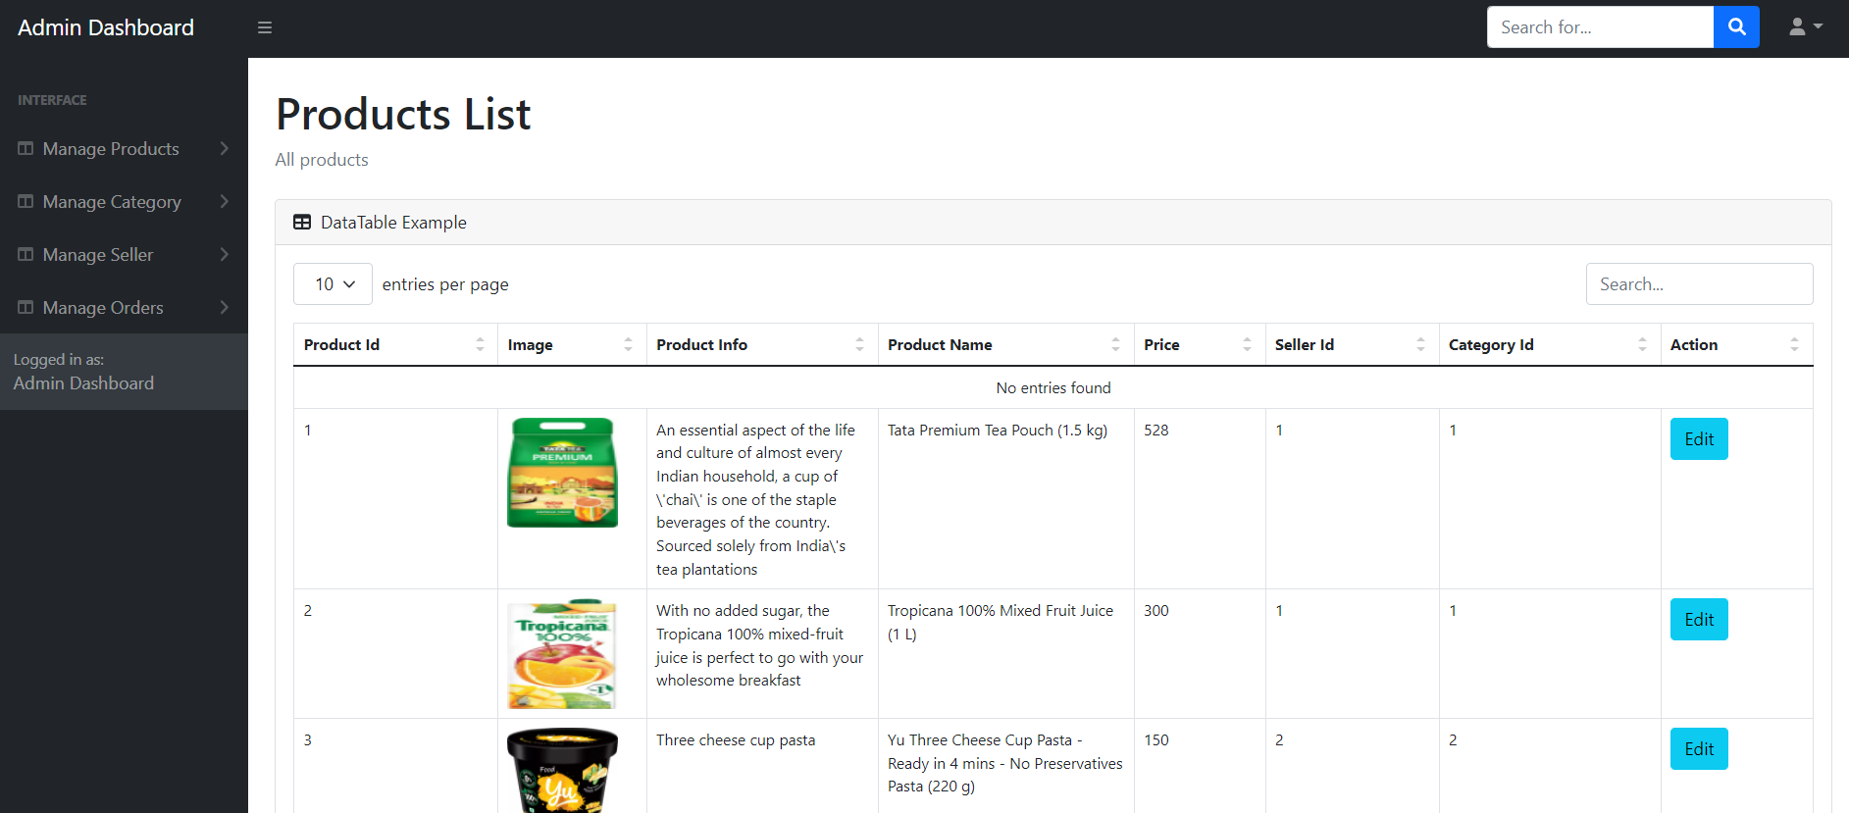

**Thank you**